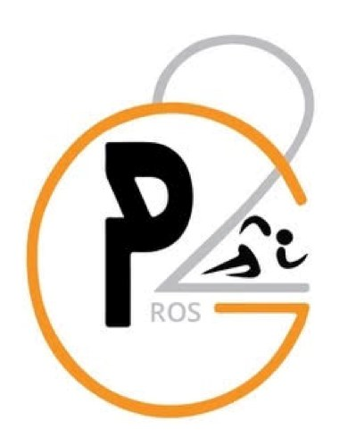 ***Hip-Hop Class***

# Prior Preparation Prevents Poor Performance

Our program builds a physical foundation through sports activities and life skills, while also building stronger social, emotional, and leadership skills through our dynamic curriculum. **Where –** 2418 west swan avenue, Tampa, Fl, 33609

**Time and Day**

Hip-Hop**-** Starting Day September 30th 3:30-4:15 **Pay**- $65/month

Visit the following website to sign up and get started!

**www.pros2go.pro**

Follow the steps to help get your child get started in Jazz/Soccer/Hip-Hop Classes today!

1. Visit www.pros2go.pro and click on **School Signup** at the top
2. Click **Register Now** at the top right-hand corner of the page
3. Fill out the New Customer Registration Form and **create an account**
4. Once the account has been made, go to **Shopping** on the left side and click on **Shop for Classes**
5. Select **Ballet, Soccer, or Hip-Hop-** Bridgeprep
6. Follow the prompts to **add a new student** and for the billing information **Pros2Go Contact Information:**

Rafael Mittag 772-766-3776 pros2go.ro@gmail.com